INTEGRATIVE COURSE IN PSYCHOLOGY (ICOPSYCH)
ANALYSIS ON THE RESULT OF POST-TEST EXAMINATION IN ABNORMAL PSYCHOLOGY
MARCH 15, 2025

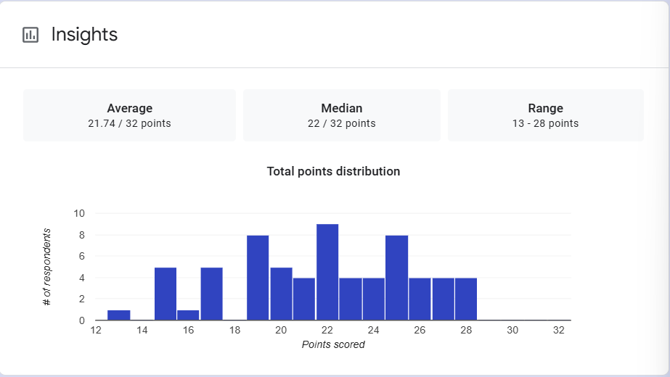
1. Mean Score: The mean score indicates that, on average, students scored approximately 21.74 out of 32 points. This suggests that the overall performance is moderate, slightly below two-thirds of the total points possible. It gives a central tendency of the data, but since it's an average, it could be influenced by extreme scores (very high or low).
2. Median Score: The median score is 22, which means that 50% of the students scored below 22 and 50% scored above 22. The median being close to the mean suggests that the distribution of scores is relatively balanced and there are not extreme outliers pulling the mean too far in one direction.

3. Range: The range of 13 to 28 points shows that the highest score was 28 and the lowest score was 13. This indicates a variation in student performance. While the scores don't fall at the extremes of the scale, there is a spread in performance, with scores ranging from 13 to 28.

Interpretation Summary:

-The class's overall performance is fairly average, with most students scoring slightly above 21 points out of 32.

-There is some variation in performance, as the lowest score was 13 and the highest was 28, but most students seem to be clustered around the median of 22.

-The fact that the mean and median are very close to each other suggests a relatively balanced distribution of scores, without significant skewing towards very low or very high performance.

RATIONALIZATION:

DIFFICULT QUESTIONS:

